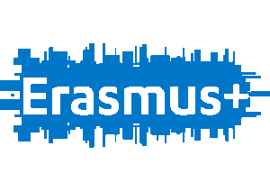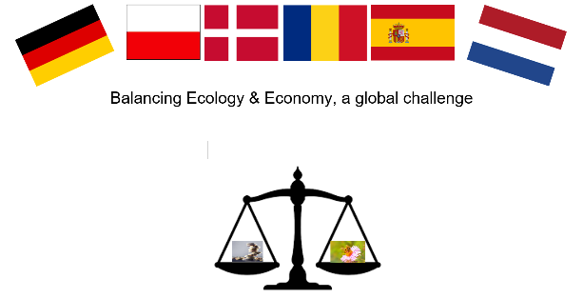
Project meeting in Week 49 in Ede
(Sunday 1 December until Saturday 7 December)
‘Balancing Ecology & Economy, a global challenge’!

Sunday 1 December
Arrival of the guests during the day.
Host Families pick up their guest at the station Ede-Wageningen.
Teachers go to hotel in Arnhem by train.

Monday 2 December
Welcome at school around 09.30 hour
Dutch students lead their guests in groups through the school (both buildings)
Teachers look around the school lead by Dutch teachers.
Welcome bye our Principal in the auditorium (main building) Around 10.00 hour

Starting program:
What do you expect of this meeting/project? 10.30 hour
- Looking at Pad let results: put your thoughts on the board!
Presentations “Our school and our team”
Lunchtime 12.50 – 13.30

Presentations
“Economy and ecology in my region and country – focusing on benefits”;
14.30 – 15.30
- student activity: “Benefits from economy and ecology”
- students talk to different students through cooperative learning structures e.g. “Mix and Match” and reflect on the benefits of economy and ecology

Teachers return to Arnhem

Tuesday 3 December
At school at 08.30 hour (auditorium main building)
Morning Program
By bus: visit Nioo-Knaw (Wageningen) - Netherlands Institute of Ecology (https://nioo.knaw.nl/en).
09.00-10.00 Lecture about the benefits of waste (shit is gold).
10.00 – 11.00 after the lecture guided tour through the building of Nioo.
Back to school by bus:
Around 12.00
Student activity: “The conflict between ecology and economy – a first approach/glimpse”
- students talk about the different conflicts between economy and ecology shown in the exhibition
- in mixed groups students pin out on post-its possible conflicts they see/realize from the information shown in the posters

14.00 – 15.30 hour
- team building activities: students work in mixed groups in scout activities to emphasize the benefits of spending time in nature

Teachers leave for Arnhem

Wednesday 4 December
Morning program
Visit the National Park (Hoge Veluwe) looking at diversity.
Lunch 12.00 – 13.00 hour

13.00 – 14.30
Visiting the garden of the school and the flat roof of the Junior-building as ways for schools to contribute to a greener environment!
What can we do more for improve diversity of flora and fauna?
Time to visit Ede Centre.

Teachers leave for Arnhem’

Thursday 5 December
Assemble at station Ede-Wageningen at 09.30 hour
Travelling by train to Amsterdam
Walking to the Dam
Taking group pictures
Group going on to the Vondelpark.
First we visit the Vondelpark for guided tour around 11.00-12.00
Second, we visit Rijksmuseum 12.30 – 13.30

Free time from 13.30 until 18.00 hour then everybody has to be at Central station Meeting Point in front of the Train station.
Travel back to Ede (18.30) arrival around 19.30.

Friday 6 December
At school at 10.00-hour Auditorium Main Building.
Evaluation of the project meeting – was the project meeting what you expected?
Products;

12.00 hour visit by St. Nicolas.

14.00-hour free time students
Teachers meeting about second project meeting

At 17.50 gathering at Bowling, centre Groeneveld (Ede) for dinner and bowling.
De Halte 19, 6711 NZ Ede

Saturday 7 December
Guests leaving from Station Ede- Wageningen

