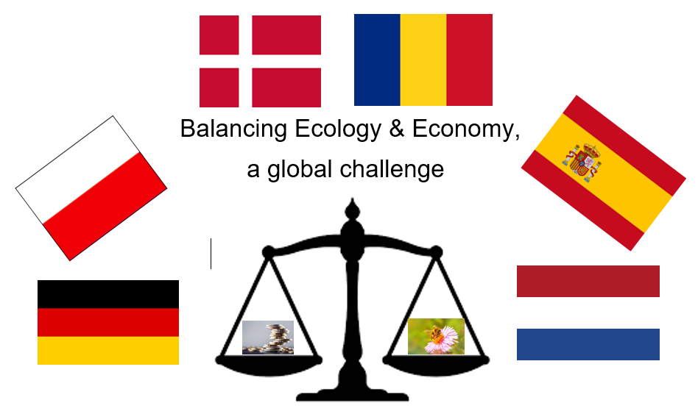
BALANCING ECONOMY AND ECOLOGY

WELCOME TO SPAIN: SCHEDULE STUDENTS

Ideas and Solutions – Finding a Balance. What are our possible individual contributions to creating and maintaining the balance and how can I put them into action?

Monday 14^{h}. We start up!

 | 9:30h-9:40h | Welcoming and presentation: José Antonio Alba and Paloma Merino. Click here to join the meeting  Evaluation: What do you expect from the project meeting in Madrid, Spain?
 | 9:40h-10:30h | Gathering and engaging. Find someone who…
 | 10:30h-10:40h | Fun Fact (Spanish Europe Club)
 | 10.45h-11:40h | Presentation: “Our School – Contributing to the balance between economy and ecology”  (Students from each country present to the rest of the group)
 | 11:40-12:15 | Break
 | 12:15- 12:30h. | Virtual tour to the Sagrada Familia de Urgel School.
 | 12:30h-13:30h | How can I contribute?  Students have to document in pictures how they can contribute to the balance between economy and ecology.  (Each day students are given one hour in which they have to document in pictures how they can contribute to e.g., producing less waste, reject driving a car, … E.g., picture of them standing at a bus stop)
 | 13:30h-14:30h | Teachers meeting

Tuesday 15th: How to reduce?

 | 9:30h-10:00h | Games to foster interaction among the students. Click here to join the meeting
 | 10:00h-10:45h | Presentations: "How to reduce the use of plastic and paper at school"  (students from each country present to the rest of the group)
 | 10:45h – 11:15h | Break
 | 11:15h-12:30 | What and how can I contribute?”  (Students in smaller teams collect all ideas from all schools and discuss which actions can be taken on an individual level)  Students make list of ideas and then smaller teams are assigned to one issue each day
 | 12:30h-13:00h | Students have to document in pictures how they can contribute to the balance between economy and ecology.

Wednesday 16th: How can I contribute?

 | 9:30h-9:45h | Games to foster interaction among the students. Click here to join the meeting
 | 9:45h-11:15h | Corrosion Workshop  (Spanish Team will send the guideline to do it)
 | 11:15h-11:45h | Break
 | 11:45h-13:00 | “Questionnaire: Am I responsible and what am I willing to do?”  (Based on student ideas/collages they prepare questions for a student survey with the title “Am I responsible and what am I willing to do”)
 | 13:00h-13:30h | How can I contribute?  Students have to document in pictures how they can contribute to the balance between economy and ecology.

Thursday 17^{th:} Workshop time
 | 9:30h-9:45h | Games to foster interaction among the students. Click here to join the meeting
 | 9:45h-11:15h | Thermofusion workshop (Part 1)  (Spanish Team will send the guideline to do it)
 | 11:15h-11:45h | Break
 | 11:45h | Each school will conduct a visit, workshop to raise awareness of a more sustainable economy and prepare a short presentation of the activity for the next day.

Friday 18th: At the end of the week....

 | 9:30h-11:00h | Thermofusion workshop (Part 2) Click here to join the meeting
 | 11h-11:30h | Show pictures of the visit / workshop of the day before.
 | 11:15h-11:45h | Break
 | 11:45-13:00h | Photo Journal: students share photos, arrange them into a presentation. Students work in smaller teams for the different issues.  Teachers meeting meanwhile.
 | 13:00-14:00 | Spanish Students present the collective Questionnaire.  Students show the different slides of Photo Journal.  Questionnaire asking for your opinion about the Spanish week.  Closing and see you soon

